

Equine Parasitology

Traditional deworming strategies, such as rotational deworming, are no longer adequate due to increased parasite resistance, and changes in parasite populations. Currently cyathostomes (small strongyles) are considered the major parasite of concern in adult horses, and Parascaris equorum (ascarids) in foals. Rather than frequent treatments with dewormer, properly timed effective treatment is recommended.

The goal of parasite control is to limit parasite infection, and to keep your horse healthy and performing well.

The amount of eggs shed by horses is highly variable within a population (ie: a few horses often shed the majority of eggs found in a pasture). Fecal egg counts allow us to determine whether your horse is a low, moderate or high egg shedder. In a healthy horse, on a farm with good pasture management, this tends to stay similar throughout your horses lifetime (ie: a high shedder will most likely always be a high shedder). Fecal egg counts are a simple and inexpensive test, in which a fresh manure sample is examined under a microscope. With the information attained by this test, we can set-up a deworming program that is suitable for your individual horse.

In addition to an effective deworming program, good management is essential for minimizing parasite infections. Some helpful hints include having an appropriate pasture size for the number of horses housed, cleaning pens and disposing of manure, rotating pastures, housing horses according to age (foals and weanlings separate from the adults), feeding off the ground, and removing bot eggs from your horses haircoat.

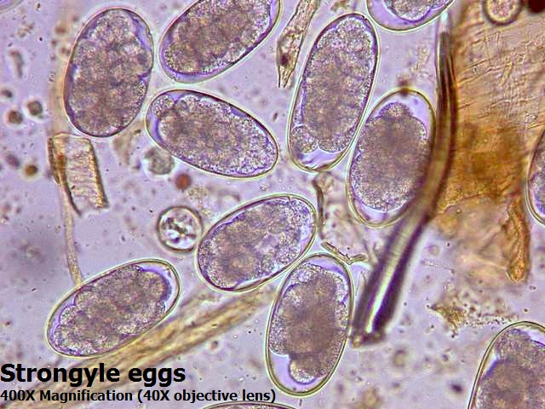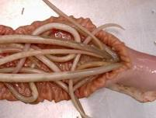
Strongyle Eggs Parascaris Equorum

If you have any questions about parasites and deworming, please don’t hesitate to call us at the clinic (780-662-0112) or to email me at e.robinson@westwindvet.com

Emily Robinson, DVM

